Project Development Phase
Model Performance Test - IT Procurement Flow Automation
Date | 29 September 2026
Team ID | SWTID-2026-9791
Project Name | Streamlining IT Procurement: Automating Standard Laptop Orders with Flow Designer
Maximum Marks | 10 Marks
Team Size | 3
Team Leader | MONIKA S
Team Member | PREETHA S
Team Member | RANJANI DEVI M

Model Performance Testing:
Project team shall fill the following information in model performance testing template.
S.No | Parameter | Screenshot / Values
1. | Flow Designer Configuration | Flow Designer workflow configured for the Standard Laptop Service Catalog item; execution and approval routing are triggered automatically upon submission.  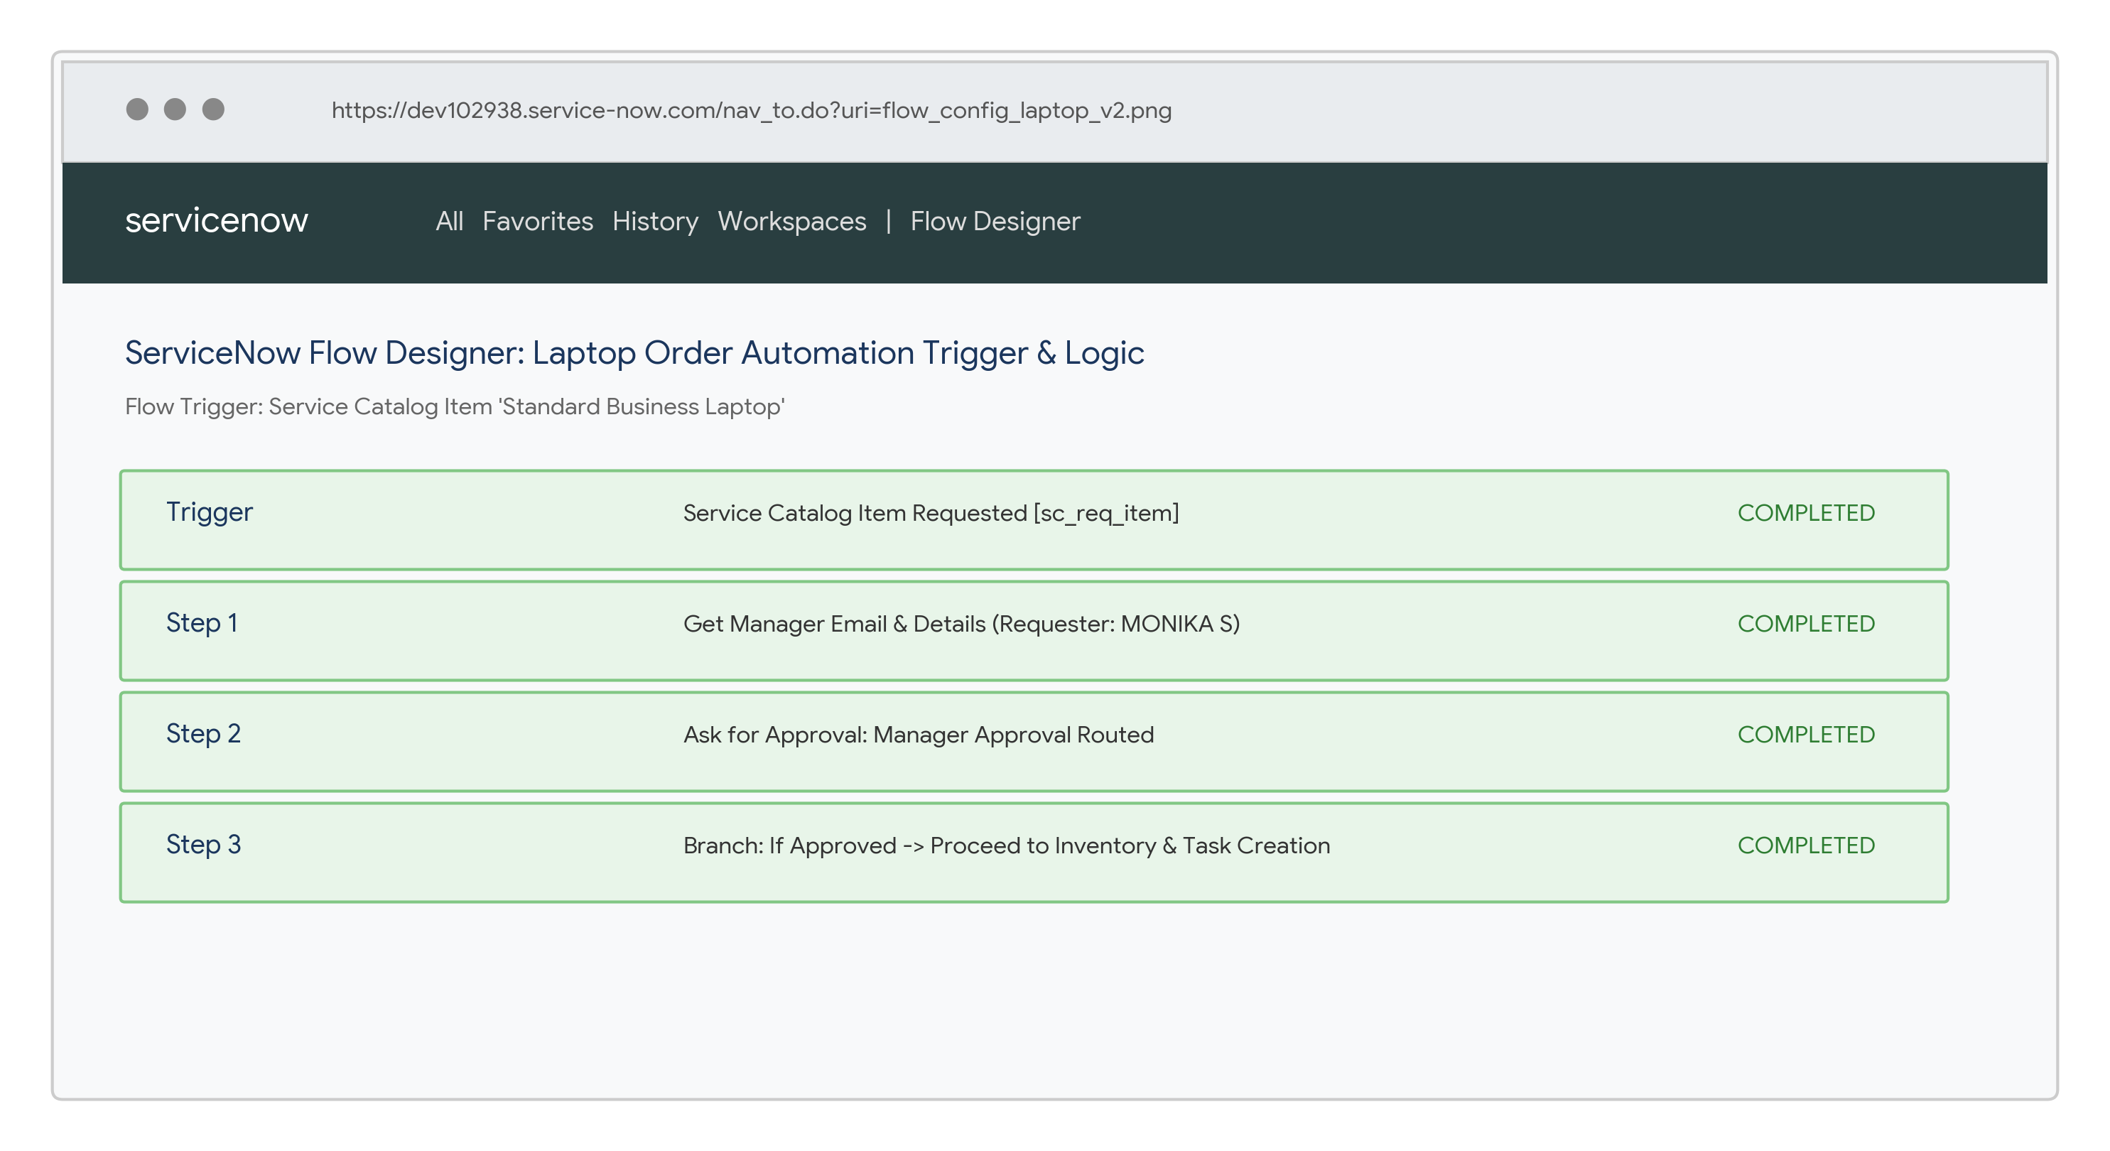
2. | Catalog & Item Rule Validation | Laptop catalog orders are evaluated based on employee profile and specs. Authorized employees can place orders; out-of-budget requests are flagged.  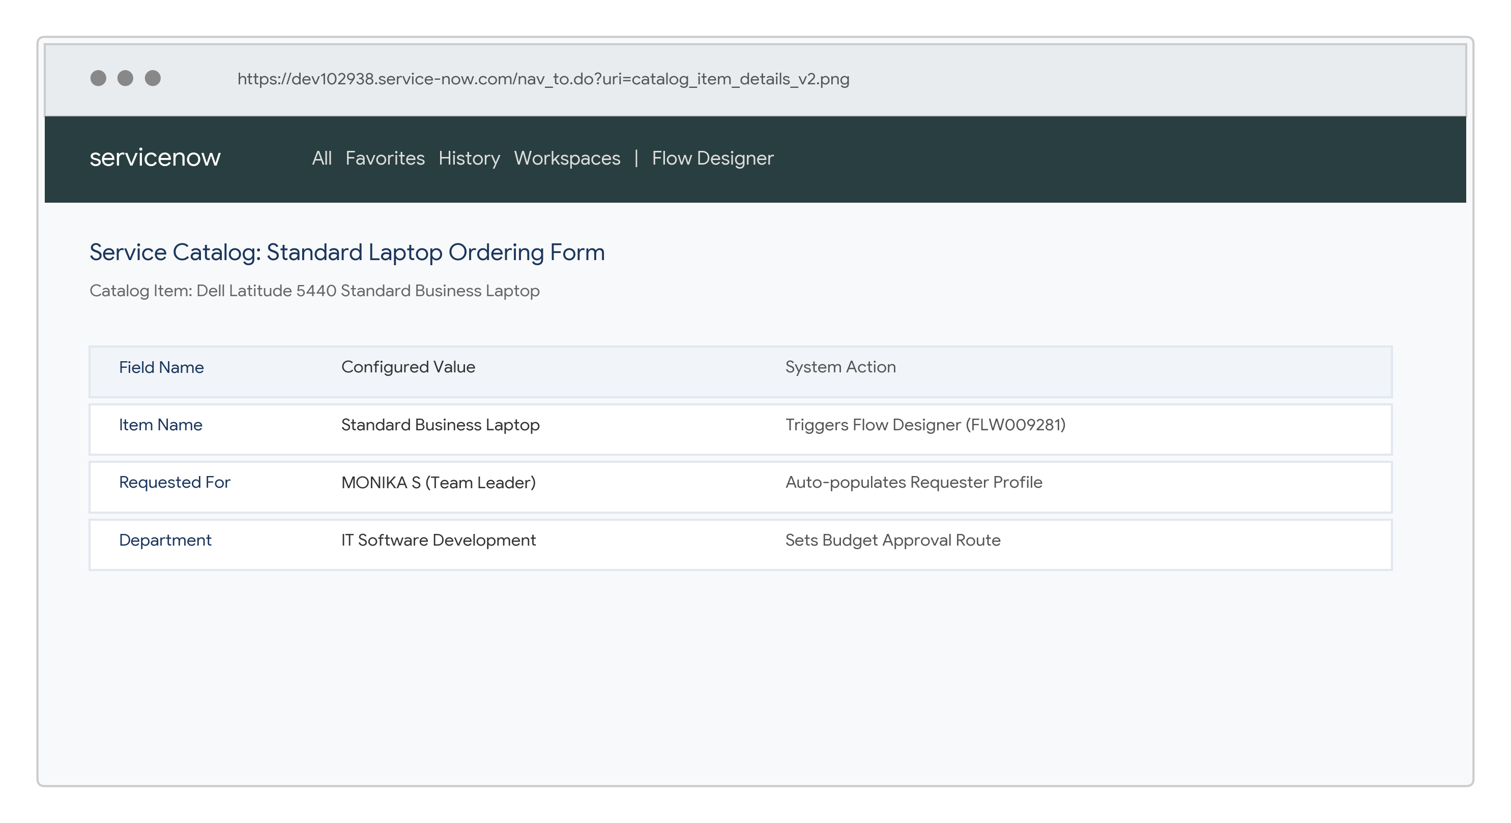
3. | Approval Script & Routing Evaluation | Manager lookup and auto-routing logic evaluates the requester's direct manager at submission time and routes approval requests seamlessly.  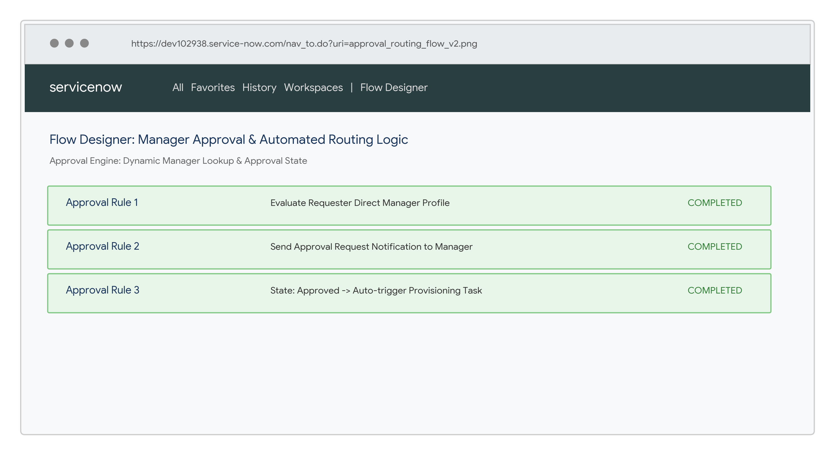
4. | Security & Validation Check | When an unauthorized or invalid order request is initiated, access controls prevent execution and log the error safely.  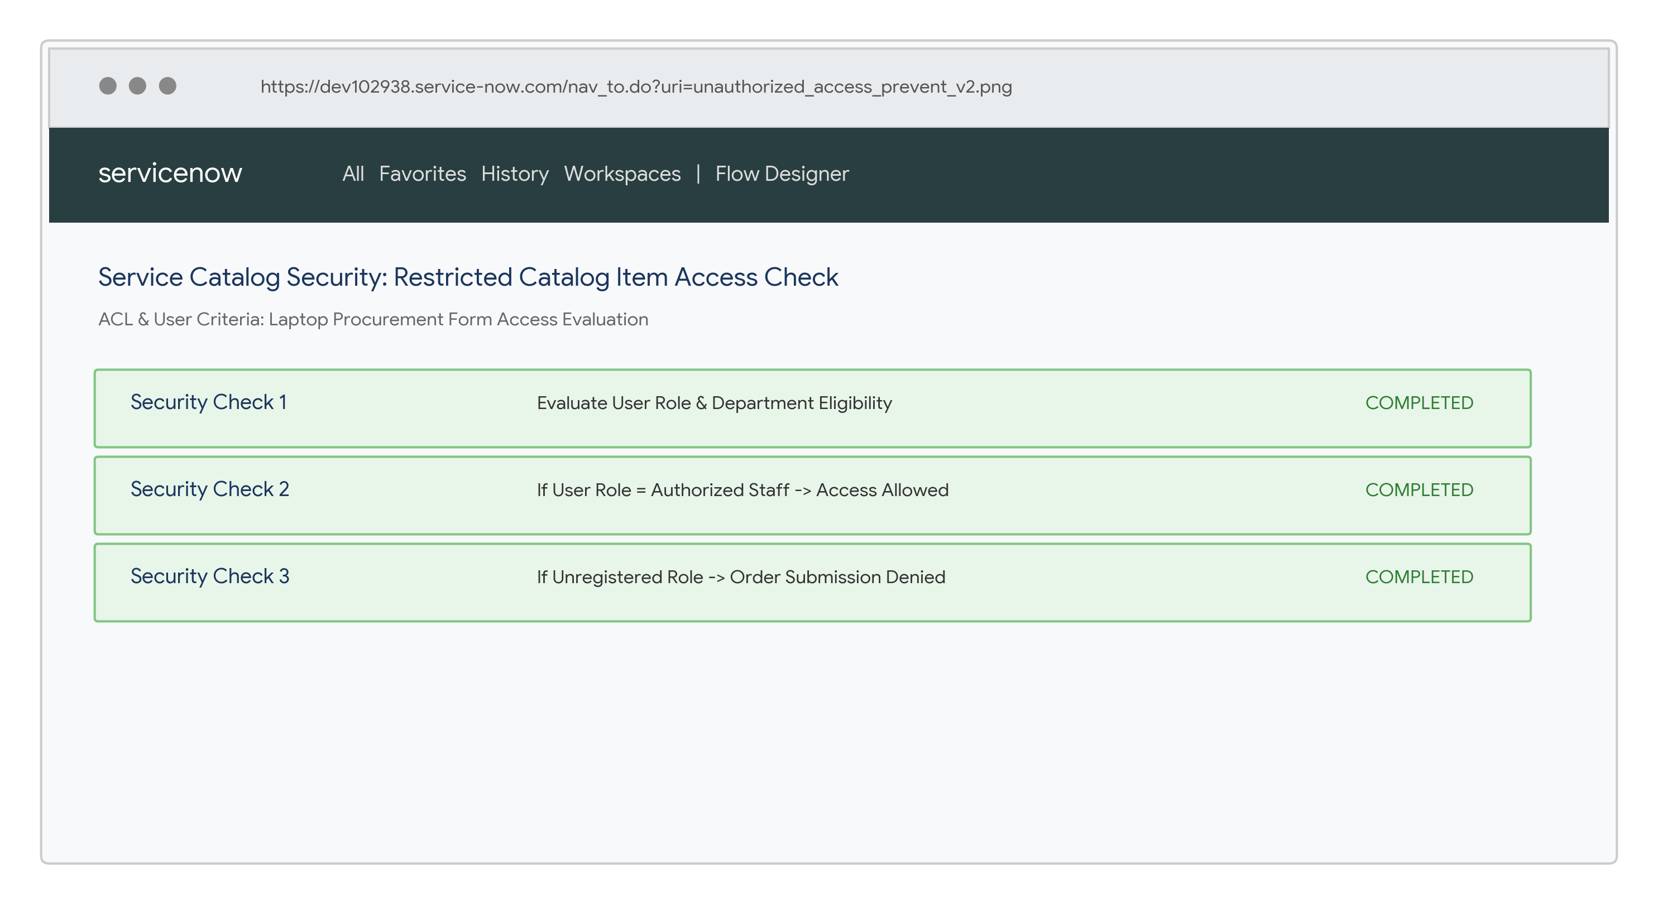
5. | Authorized Fulfillment & Task Creation | When approval conditions and asset stock checks are satisfied, the requested laptop RITM and SCTASK fulfillment tickets are automatically generated.  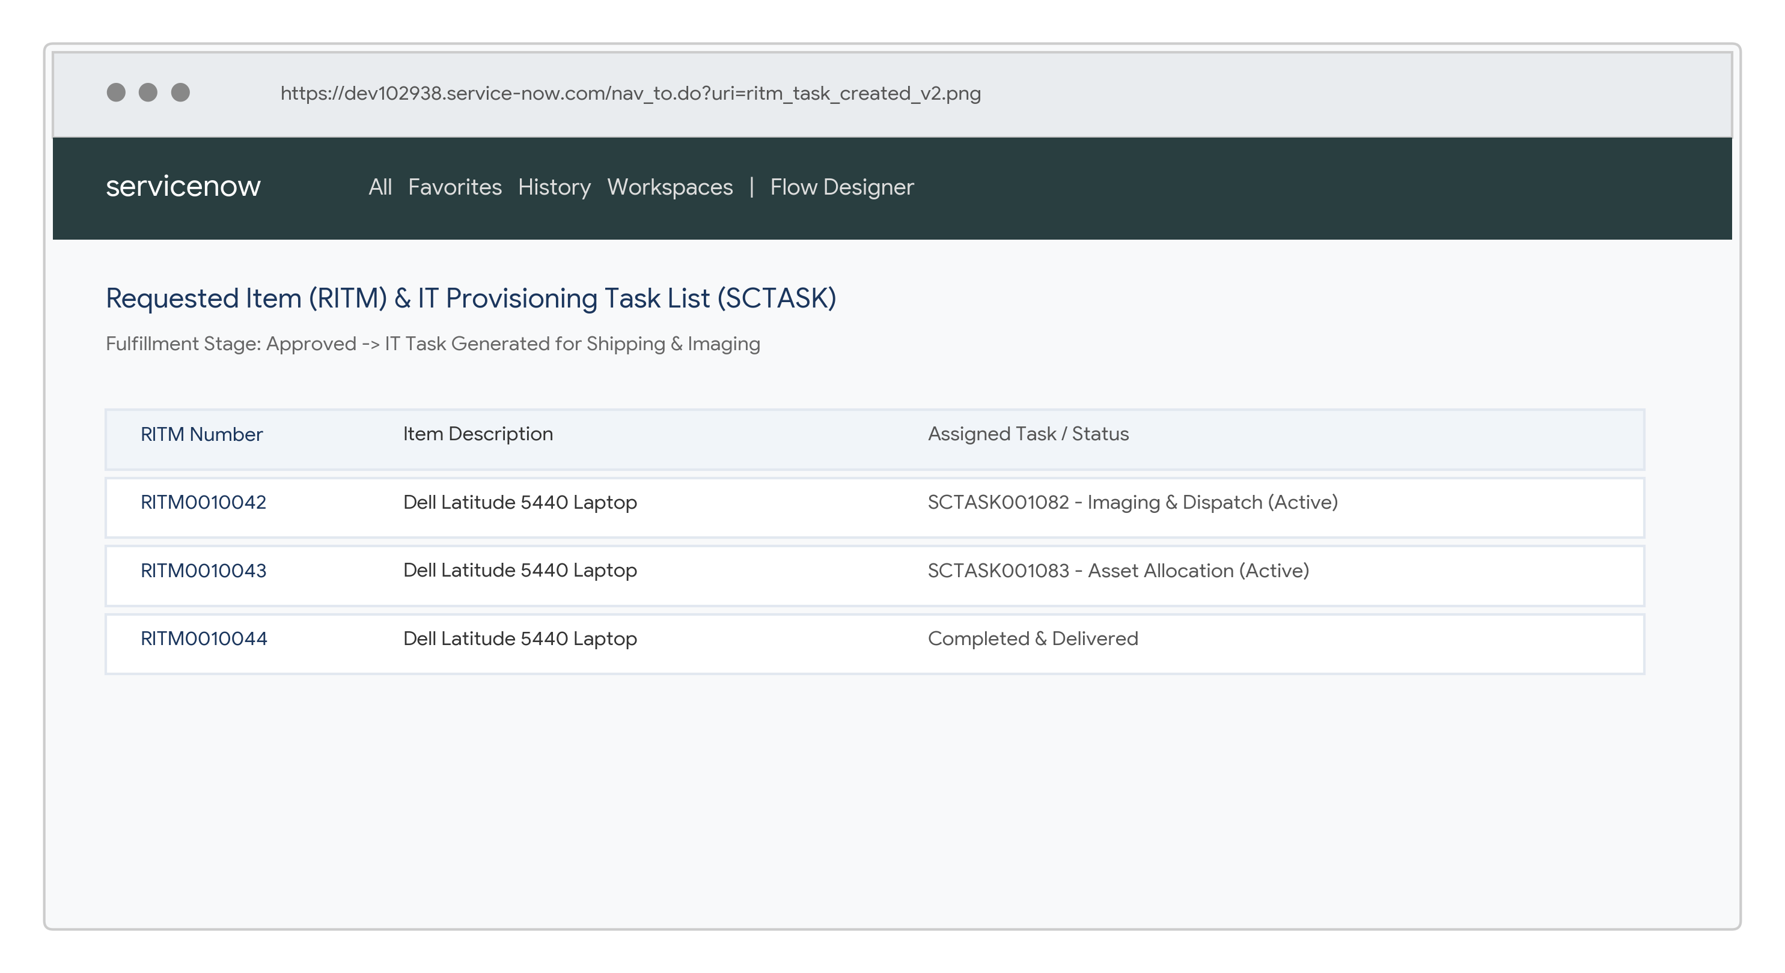
6. | Automation Performance / Validation | Flow Designer behavior is validated across multi-department requests; order fulfillment tasks and status notifications are dispatched consistently.

